# Pizza Sales (SQL QUERIES)

**A.KPI’s**

**1. Total Revenue:**

select sum(total_price) as total_revenue from pizza_sales;

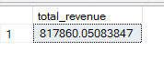

**2. Average Order value:**

select sum(total_price)/ count(distinct order_id) as avg_order_value from pizza_sales;

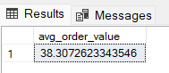

**3. Total Pizza Sold:**

select sum(quantity) as Total_pizza_sold from pizza_sales;

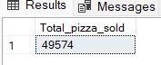

**4.Total Orders Placed:**

select count(distinct order_id) as Total_orders from pizza_sales;

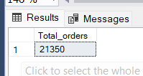

**5.Average Pizza Per order:**

select cast(cast(sum(quantity) as decimal(10,2))/

cast(count( distinct order_id) as decimal(10,2)) as decimal(10,2)) as Average_pizzas_per_order from pizza_sales;

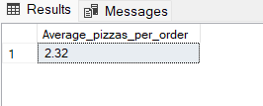

**B. Chart Requirement**

**1. Calculate the week day and Its orders:- or Daily Trend of orders**

select DATENAME(DW,order_date) as Day_name,count(distinct order_id) as Count_of_orders from pizza_sales group by DATENAME(DW,order_date);

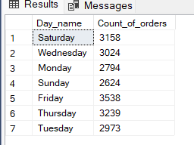

**2. Monthly Trend of Orders:-**

select DATENAME(MONTH,order_date) as month_name,count(distinct order_id) as Total_orders from pizza_sales group by DATENAME(MONTH,order_date) order by 2 desc;

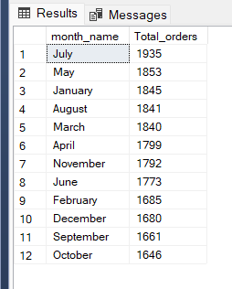

**3.% of Sales by Pizza Category:**

select pizza_category,sum(total_price) as total_sales,

cast(sum(total_price)*100/(select sum(total_price) from pizza_sales) as decimal(10,2)) as PCT from pizza_sales

group by pizza_category;

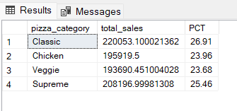

**4. % of sales by Pizza Size:**

select pizza_size,cast(sum(total_price) as decimal(10,2)) as Total_sales,

cast(sum(total_price)*100/(select sum(total_price) from pizza_sales) as decimal(10,2)) as PCT from pizza_sales

group by pizza_size;

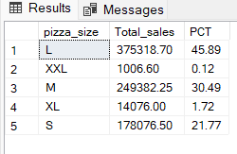

**5.Top 5 and Bottom 5 Sales of Pizza:**

**Top 5**

select top 5 pizza_name,sum(total_price)as Total_sales from pizza_sales group by pizza_name order by 2 desc;

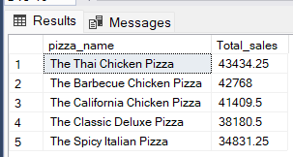

**Bottom 5**

select top 5 pizza_name, cast(sum(total_price) as decimal(10,2))as Total_sales from pizza_sales group by pizza_name order by 2 asc;

